**Edu Tutor AI: Personalized Learning**

GenerateAIwithIBM



**PROJECT DESCRIPTION:**

EduTutor AI is an AI-powered personalized learning assistant developed using Hugging Face’s state-of-the-art NLP and transformer models. The project focuses on enhancing digital education by providing intelligent tutoring, real-time doubt solving, and adaptive learning paths for students.

**PRE-REQUISITES:**

1. Gradio Framework Knowledge: Gradio Documentation

2. IBM Granite Models (Hugging Face): IBM Granite models

3. Python Programming Proficiency: Python Documentation

4. Version Control with Git: Git Documentation

5. Google Collab’s T4 GPU Knowledge: Google colab

**PROJECT WORKFLOW:**

Step-1: To write a code for EduTutorAI in GoogleColab.

Step-2: Choosing a IBM Granite Model From Hugging Face.

Step-3: Running Application In Google Colab.

Step-4: Upload your Project in Github.

*. Open Google Colob and save it as EduTutorAI.ipynb and open a new notebook in Google Colob.

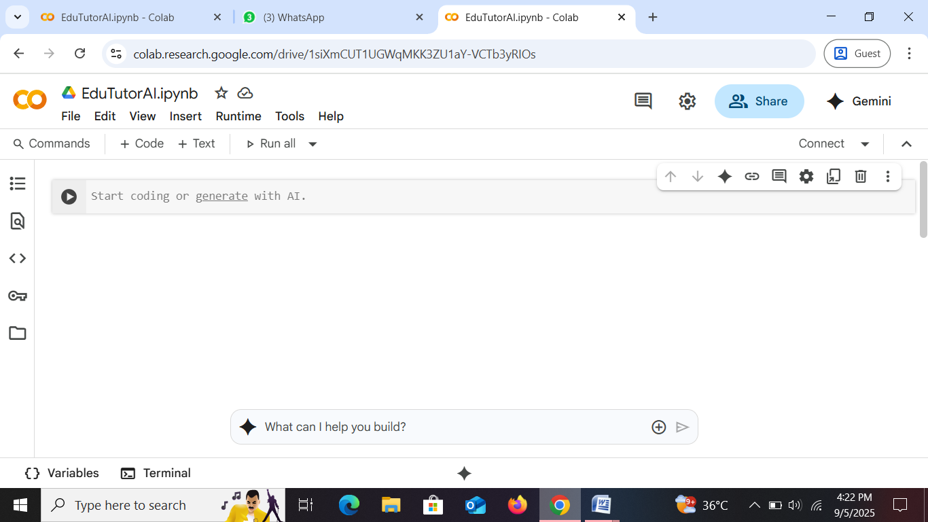

● Search for “Hugging face” in any browser.

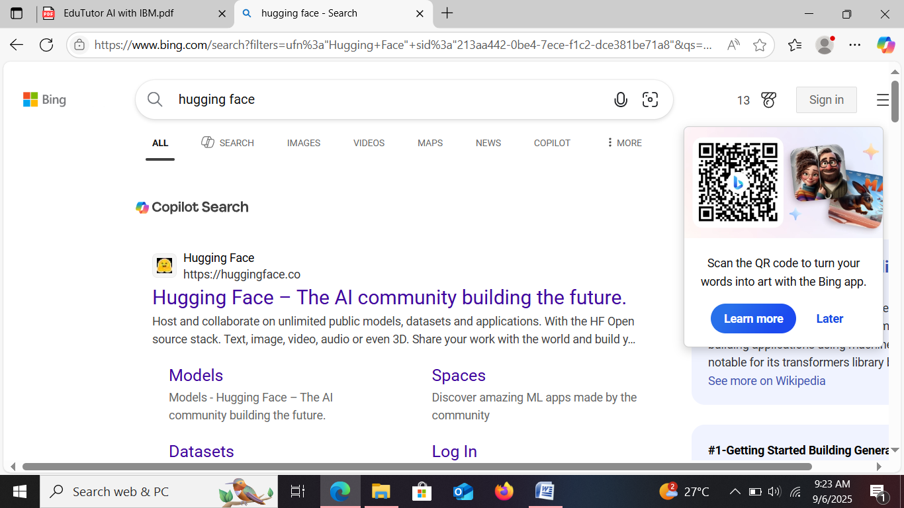

● Then click on the first link (Hugging Face), then click on signup and create your own account in Hugging Face. Then search for “IBM-Granite models” and choose any model.

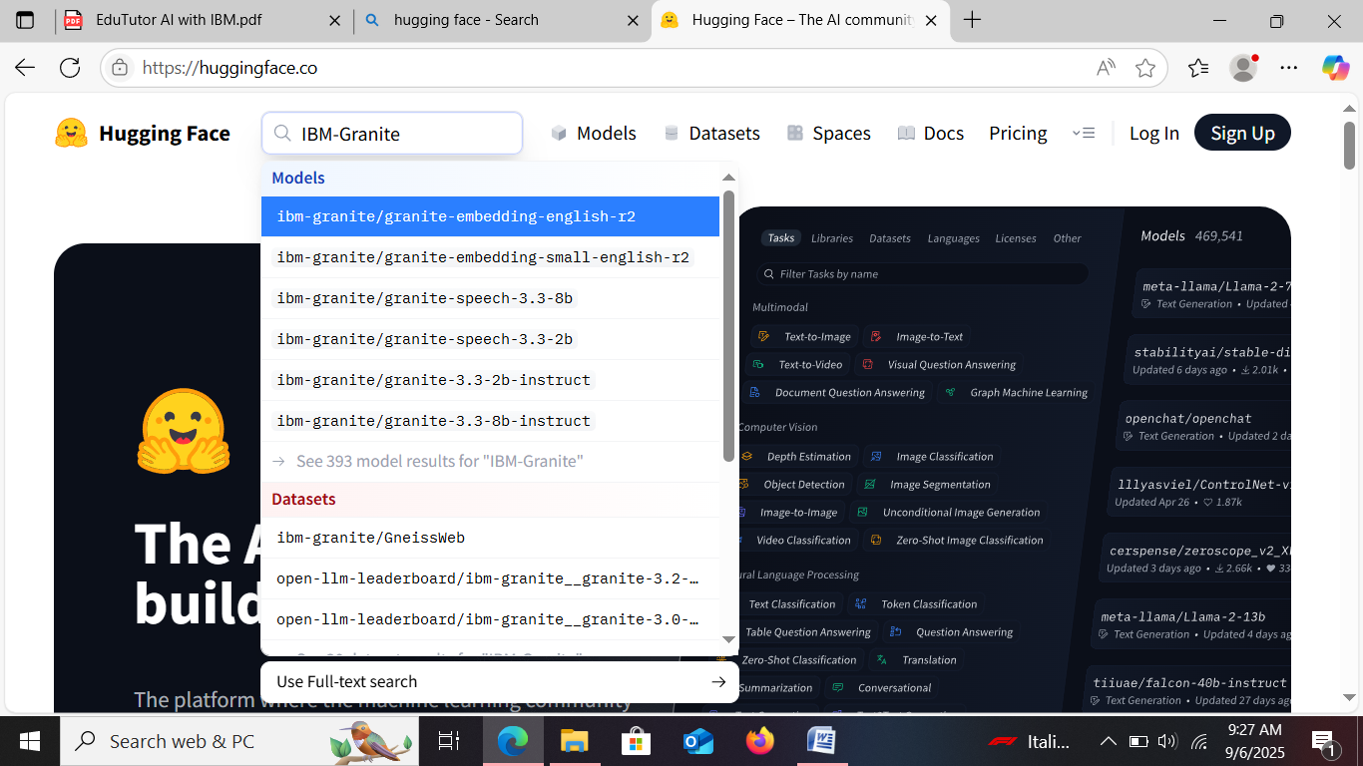

● Here for this project we are using “granite-3.2-2b-instruct” which is compatible fast and light weight.

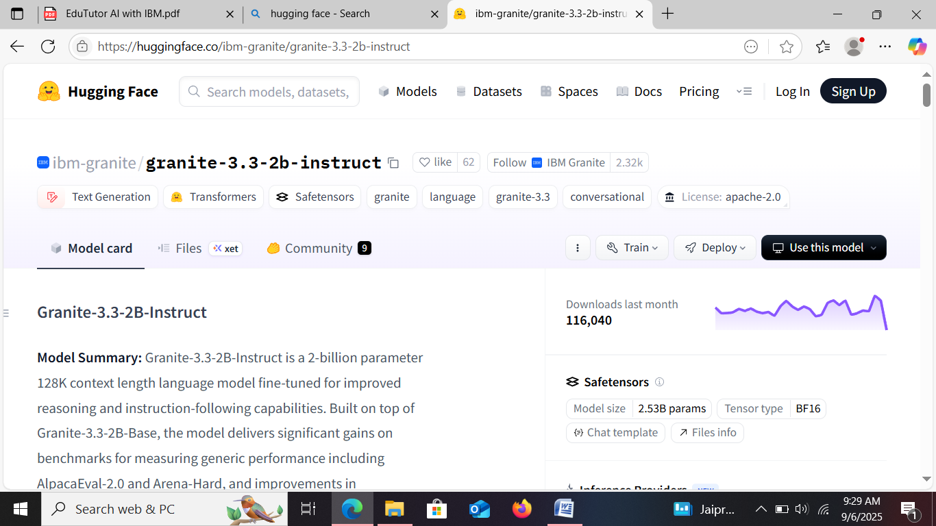

● Now we will start building our project in Google collab.

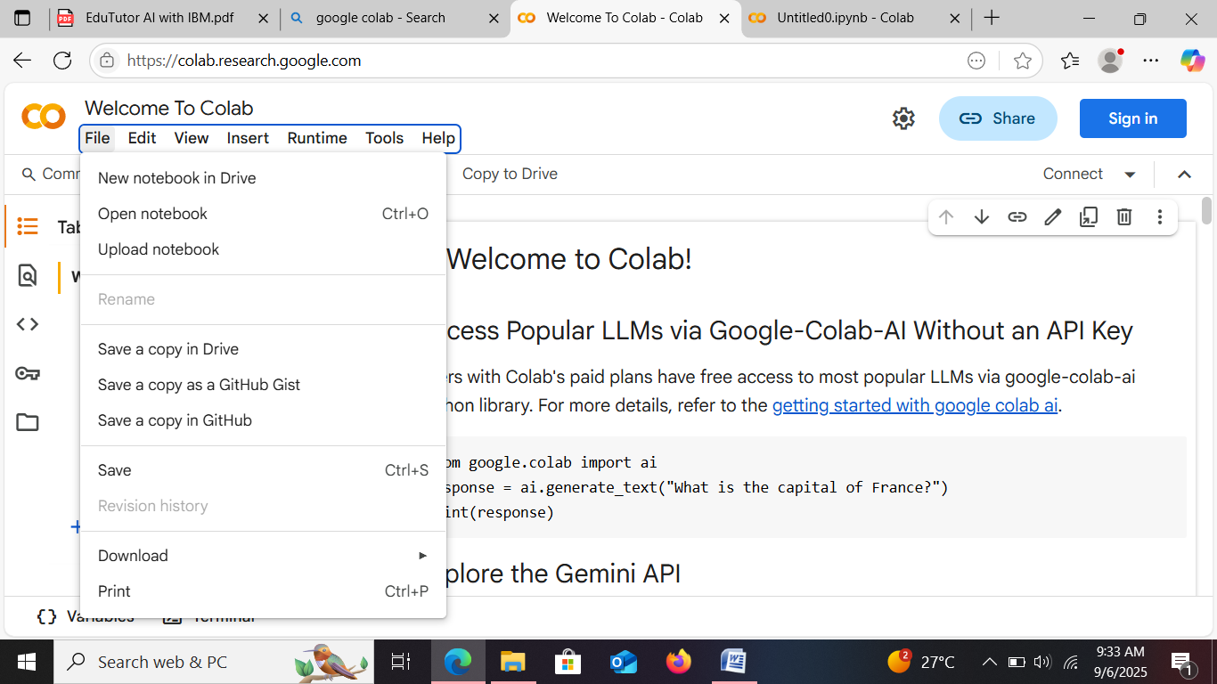

*. Choose “T4 GPU” and click on save.

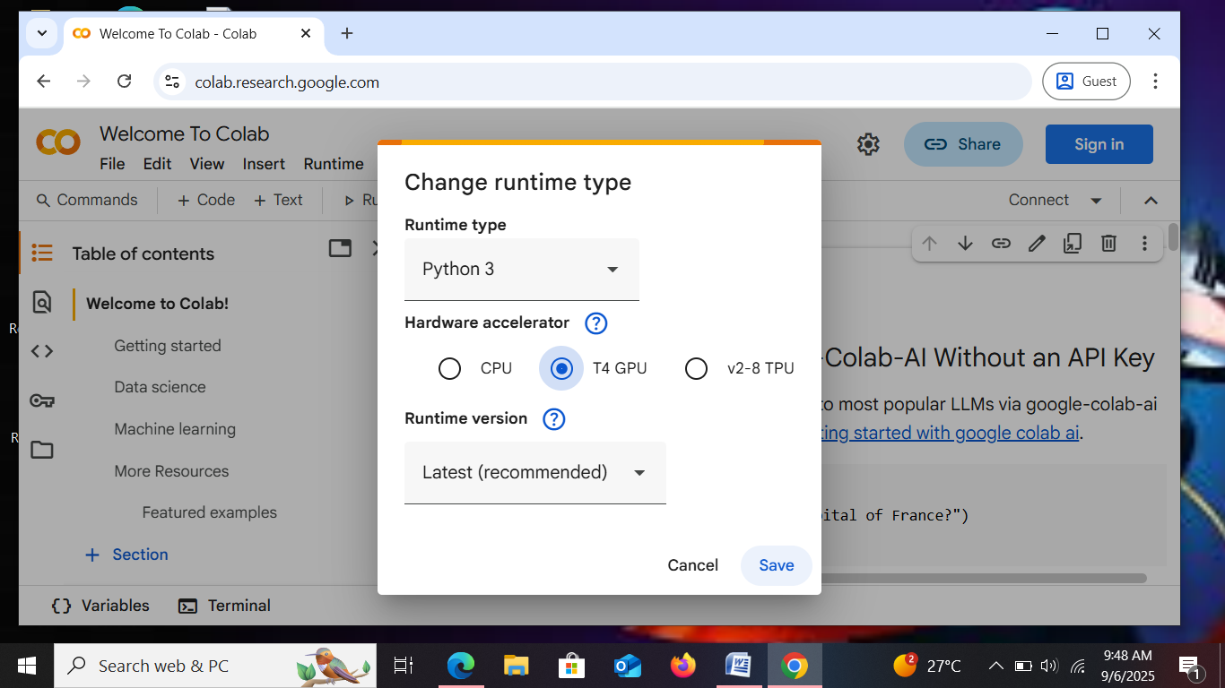

● Then start doing the code for “EduTutorAI” .

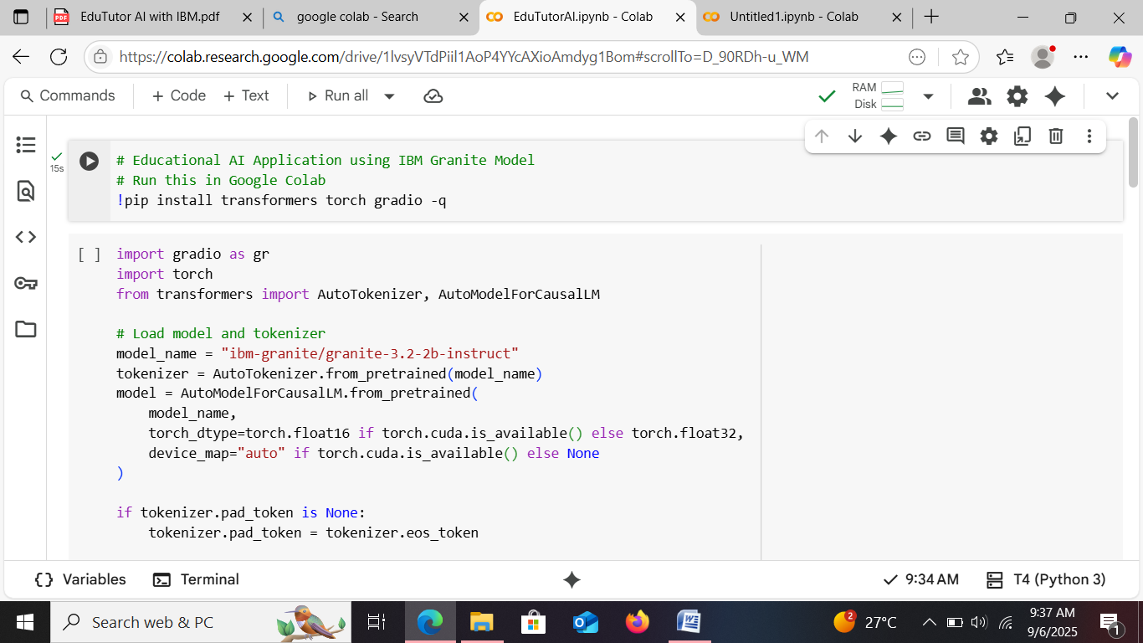

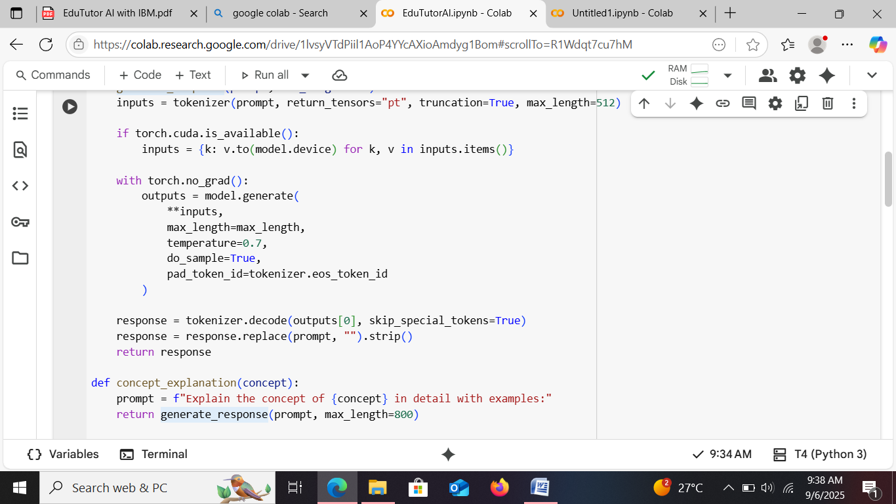

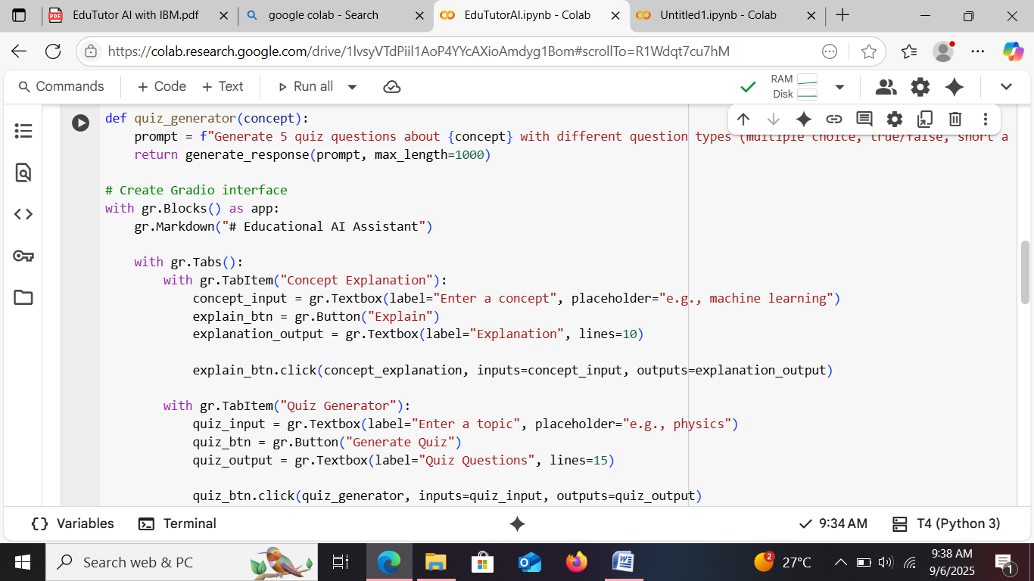

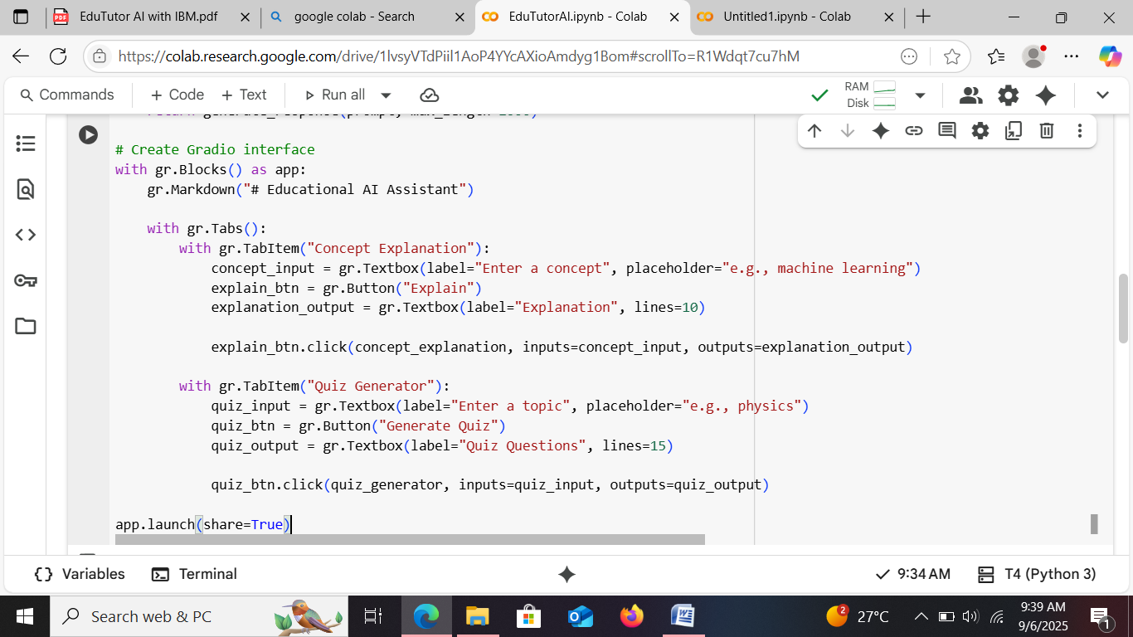

**OUTPUT:**

